

**Uncertainty, the Implementation of Monetary Policy and the Management of Risk**

Speech given by

Paul Tucker, Member of the Monetary Policy Committee, Bank of England 19 May 2006

1

All speeches are available online at [www.bankofengland.co.uk/publications/Pages/speeches/default.aspx](http://www.bankofengland.co.uk/publications/Pages/speeches/default.aspx)

## ASSOCIATION OF CORPORATE TREASURERS, NEWPORT, 19 MAY 2006 UNCERTAINTY, THE IMPLEMENTATION OF MONETARY POLICY, AND THE MANAGEMENT OF RISK

Many of us would probably say that we do not much like uncertainty, whether at work or home. But we cannot escape it, and it provides opportunities. Rather, we want to be compensated for the risk, or to mitigate it, or both.

What I think we actively dislike is avoidable uncertainty. And from the point of view of society, we should dislike uncertainties that are both avoidable and especially costly to mitigate for those who bear the consequent risks.

I am going to discuss some sources of avoidable uncertainty – or volatility – that have affected you as corporate treasurers. And I will discuss some unavoidable sources of uncertainty, and what they might mean for risk management, at the level of firms and of the financial system as a whole.

## Avoidable uncertainties: the monetary regime, and the implementation of monetary policy

For too many years in the UK, we lived with a large but avoidable element of macroeconomic uncertainty. It was unclear what rate of inflation households and businesses should expect to prevail over the medium- to-long run. In other words, it was unclear what policymakers were trying to achie ve; whether their goals shifted about; and whether policy makers would succeed in delivering those goals. That was resolved progressively during the 1990s, culminating in the Government’s announcement in 1997 that an operationally independent Bank of England was charged with achieving a clear inflation target. A stable monetary environment has reduced the quite unnecessary risk of self- induced ‘boom and bust’ flipping about demand conditions across the economy as whole.

For users of financial markets, the most visible sign of the change was the reduction in yields on conventional government bonds with long maturities, which had previously compensated for high and highly uncertain prospective inflation rates. By ushering in a world with a credible nominal anchor, one source of uncertainty and risk was significantly reduced. The *ex post*

annualised volatility of ten year gilt yields has halved: from over 200 basis points between 1970 and 1997, to under 100 basis points since the current monetary regime was introduced (Table 1).

That means that, as corporate treasurers, one source of unavoidable uncertainty about your long- run borrowing costs has been very significantly reduced.

The introduction of the new monetary regime did not, and of course could not, remove uncertainty about the quarter-to-quarter, or indeed year-to- year, path of the economy and inflation. And so there remains a degree of unavoidable uncertainty about the short-term path of official rates, as the Monetary Policy Committee responds to cyclical developments.

Transparency can reduce that uncertainty, through our making clear what we think is going on in the economy and how, generally, we react to changes in the outlook. We do that through the minutes of our monthly meetings and the quarterly Inflation Report; and, in terms of our individual analyses, through speeches, etc. But, like anybody else, we cannot predict with certainty what will happen in the economy. There are always material risks around the central outlook. We have to weigh those risks in our policy decisions in much the same way as you do in your business and financing decisions.

In the midst of all this unavoidable uncertainty, however, a few things are not in doubt. The MPC’s official interest rate is certain. So there should be no uncertainty about the general level of overnight rates in the money markets. In fact, though, overnight rates in the UK have historically been highly volatile. Various steps taken over the past decade or so moderated that volatility – with some success; it has for some while been much lower than in the mid-1990s (Chart 1). But it has remained greater – from day to day, and during the day – than overnight rates in dollars, euros etc (Charts 2 and 3).

That has created uncertainty for users of the sterling money markets – banks, asset managers and, of course, corporate treasurers. Avoidable uncertainty.

It is the Bank of England’s responsibility to remove that uncertainty as much as we possibly can. And yesterday, after more than three years’ preparation and extensive collaboration with market participants, we introduced a completely modernised system to do just that.

It provides a new framework for the Bank’s implementation of monetary policy; our operational engagement with the banking system; and for the sterling money markets.

I shall spare you the details, but I do want to sketch the main features of the system, by way of underlining that it is directly relevant to you as corporate treasurers. I am keen that you should hear this directly from the Bank.

For as long as anyone can remember, a small group of clearing banks – which these days we call ‘settlement banks’ – have had to balance their books with the Bank at the close of business each evening. Volatility resulted if the Bank had not provided pretty well exactly the amount of liquidity the banking system as a whole needed each day; or if our money was not distributed in the money markets to those banks that were short. And traders would speculate on that volatility

– perhaps a rare instance of financial market activity with little social utility.

The new system relaxes the overnight constraint and liberalises access to the Bank. A broader group of banks – initially just over 40, accounting for around 90% of the UK bank ing system’s sterling liabilities – will maintain a target balance with the Bank on average over each month. (In the first maintenance period, which started yesterday, the target is just under £23bn.) These reserve-scheme banks, and other banks who so choose, also have access to a standing deposit facility and a standing (secured) lending facility. At a modest penalty to the Bank’s policy rate, they can use those facilities in unlimited amounts, and so can turn to them if the rate in the market threatens to be less attractive. Together, this should keep the market rate in line with our policy rate.

Indeed, our objectives have been fourfold. First, to stabilise overnight market rates in line with the MPC rate. Second, to improve the efficiency of the framework for banking system liquidity management in normal conditions, and to make it more resilient in stressed conditions. Third, to simplify our method of implementing monetary policy. And fourth, to foster efficient and fair markets.

For too long, too many people have been deterred from using the short-term sterling markets as much as they might because it seemed to required special expertise, and therefore a disproportionate commitment of resources.

Judging by the ACT’s very positive response to one of the Bank’s early consultation papers, the modernisation of our framework should be helpful to companies, which of course use the money markets to borrow, employ cash balances, and manage risk.

At the end of last year, firms’ short-term sterling borrowing in the UK was around £300 bn. There are no data on how much of that was at very short maturities, but there is anecdotal evidence of overnight volatility acting as a deterrent. For example, when in late 2004 the Bank announced our intention to introduce reforms, the European treasury department of one of the largest companies in the world wrote to me in the following terms:

“I write to express our support and appreciation ….. The excessive volatility in the overnight market precluded high-quality issuers .. from participating. …The steps you are taking will surely increase the depth, stability and overall liquidity of the sterling money market.”

That kind of support has been a great encouragement.

In terms of risk management, many companies swap fixed-rate term borrowing (and other cash flows) into floating-rate. This can be into a six or three- month LIBOR rate of interest, or into a stream of payments linked to the overnight money market rate. In the UK, the Overnight-Index- Swap market has developed rather less than its counterpart in the euro area, which is used by large non- financial companies. One obstacle seems to have been the intra-day volatility in the sterling market, which has entailed uncertainty about the spread between the average overnight rate on any particular day (as measured by the Sterling Overnight Rate Index Average, or SONIA) and the rate actually paid on overnight cash at different times during the day. Many market participants believe that if the reforms introduced yesterday significantly reduce intra-day volatility, the sterling OIS swap market will grow, making it a more useful risk management tool.

The evidence of corporate treasurers as placers of short-term money is more concrete. For a few years now, UK companies’ domestic operations have been producing surplus cash flows: £12bn, or about 1% of GDP, in 2005. The counterpart has, of course, been an accumulation of financial assets. A lot of that has gone in to the money markets – in particular, holdings of call-deposits with banks (Chart 4) and investments in money market funds. In placing that liquidity, you

should be in a position where you need to negotiate only the spread paid relative to a stable money market rate, not the underlying rate itself. Our overhaul of the system should deliver that.

By taking the noise out of the sterling money markets, we aim to achieve greater stability and greater transparency. That won’t revolutionise your businesses, but I trust that it will bring a welcome reduction in the avoidable uncertainties you confront.

## Business risk management and pension-scheme uncertainties

At an aggregate level, the recent financial management of the company sector has, in fact, posed some puzzles about your assessment of uncertainty and risk. This has been important to our understanding of what is going on in the money markets, and indeed financial markets more generally, as part of the backdrop to our role of promoting monetary and financial stability.

The surplus cash flows I described earlier, in the context of your treasury management, are a product of UK cash profits having exceeded, by some margin, business investment (Chart 5). The same is true across the G7 economies as a whole. Companies have acted to repair balance sheets following the excesses of the late 1990s, and may conceivably have built a cushion of financial assets to support them through a period of uncertainty as they adjust to the new competitive forces associated with globalisation. But the UK corporate sector

stands out as having employed its surplus in ‘cash’ to a far greater extent than its G7 peers (Chart 6).

The IMF hypothesise1 that this may have been motivated by a desire to accumulate a precautionary pot of liquid savings for managing pension fund deficits. I do not know whether or not that is so. For example, the build up of deposits has been concentrated in a few sectors: real estate, and business services, and it is not obvious that these sectors have big pension fund deficits (C hart 7).

But that pensions have been a material component in firms’ cash management is not in doubt. That is apparent in the share of gross corporate savings accounted for by employers’ contributions to pension funds (Chart 8). Contributions have tripled – or in real terms

1 See footnote 18, Chapter IV ‘Awash with cash: why are corporate savings so high?’, *World Economic Outlook,* April 2006, page 151.

doubled – since the late 1990s (Chart 9)2. Part of this reflects ‘special’ or ‘one-off’ contributions to reduce deficits. But, judging by self-administered schemes3, regular contributions have doubled (Chart 10). What is going on here?

Well, it might have something to do with your management of risk, bearing in mind avoidable and unavoidable sources of uncertainty.

A corporate sponsor of a defined-benefit pension scheme is, in effect, providing a guarantee or, broadly, writing a very complex option4: one on which the present value of the payoffs is related to, amongst other things, the future growth in earnings of its workforce, their longevity, and the yield on an equivalent- maturity risk-free bond. Apart from the design of the scheme itself and the associated balance of wages and pensions in employee remuneration, the sponsor makes two big choices: the level of contributions it makes to the fund, and the asset allocation of the fund. (It may seem odd to say that the sponsor makes a decision about fund asset allocation, because of course that is formally the responsibility of trustees. But as guarantors, those decisions affect the risk run by sponsors who, in principle, could make adjustments to their own balance sheet if they regarded trustee choices as suboptimal. )

Past increases in life expectancy entail higher contributions and, other things being equal, add to the marginal cost of a firm’s labour force. An unavoidable source of uncertainty is future developments in longevity.

In the asset allocation of a fund, company sponsors face, at one remove, a trade-off. On the one hand, if a fund holds risky assets, it will earn a risk premium but its value will tend to be more volatile, varying with the long-term risk- free rate used to discount its liabilities and the value of its risky assets. On the other hand, a fund could choose to hold only risk- free assets matching the characteristics of the scheme’s liabilities; for example, buying annuities which can hedge the dur ation and lo ngevity risk in known pension liabilities. In that case,

2 For the household sector, the effect has been that employer contributions more than account for total net savings.

3 A breakdown of contributions into ‘one-off’ and ‘regular’ is available only for self-administered schemes.

They account for around half of total employers’ contributions to private pension schemes.

4 It is option-like because of the asymmetry between extracting surpluses from pension funds and making good deficits.

the fund’s expected returns will be lower, and so sponsor contributions will have to be higher in order for the fund to meet the scheme’s future obligations.

In short, company sponsors face some sources of avoidable uncertainty about the future value of their pension funds, with the level of their contributions akin to a premium paid to reduce or remove that uncertainty. (The funds’ trustees face a subtly different risk trade off, in which they need to weigh the correlation of the risks in the asset- liability mix of their fund with the risks to the sponsor’s business and net worth, and so to its capability to meet any future fund shortfall.)

How much risk a company should take in its core business and in the provision of pensions is obviously a matter for its board. A famous paper in corporate finance5 finds that, subject to some (admittedly fairly strong) assumptions about tax etc, the market value of a company (measured as the sum of the value of all its financial liabilities, equity and debt) should not depend on its capital structure. Rather, its capital structure affects the risk to equity holders, and so the headline return they should rationally require to compensate for risk. Within this framework, defined-benefit pension schemes can be viewed as deferred compensation and so as entailing a form of indebtedness (in many cases, de facto indexed- linked borrowing) for their sponsors, to be ‘serviced’ alongside their more conventional external indebtedness. Perhaps that has become most obvious when a fund is calculated as being in deficit.

It would seem that in recent years there has been a keener awareness of this way of thinking analytically about pension obligations. If there has been an ‘awakening’, maybe it was triggered by a combination of the volatility of the value of equities held by funds, especially when they fell sharply a few years ago; the volatility of the discounted value of their liabilities as long- maturity real rates fell; regulatory requirements governing the closure of deficits; and fluctuations in the net value of funds having for the first time to be reflected in firms’ capital in their financial accounts.

Firms may, therefore, have been reviewing their preferences between risk-taking in their core business and risk-taking via pension provision, and for a while may have been

5 Nobel Prize winner, Modigliani, F, and M. Miller, 1958, ‘The cost of capital, corporation finance and the theory of investment’, American Economic Review 48, 261-297.

unusually uncertain about how equity markets value those different sources of uncertainty. If so, that may conceivably offer part of the explanation for the measured recovery in UK business investment having been weak, relative to the economy’s total output, compared with past cycles (Charts 11 and 12). Some have suggested that the need to close deficits may have been a factor, via the call on cash flows. The possibility I am airing is that another factor may be the size of a scheme’s discounted liabilities and the prospective volatility of the associated fund’s net value relative to the sponsor’s underlying business and capitalisation.

I do not want to push that too far. There have, of course, been other possible explanations for weak fixed-capital expenditure. These include competition from China, India and elsewhere; the rise in oil and commodity prices; and the uncertainty about how both will play out, and thus about prospective demand for UK output. All of this might have been thought to make the external environment unusually risky and so to warrant deferral of investment decisions.

Another possible explanation is, simply, that the level of investment has been under-recorded, and that the data will be revised up, as they have been frequently in the past (Chart 13). Indeed, as the share of economic activity accounted for business and financial services increases, it is even possible that a growing part of business investment is simply unmeasured. When your teams spend time developing spreadsheets that will be used for 3-5 years, do you count that as investment?

So it is difficult to know whether or not the management of risks associated with pension provision has had a bearing on the recent measured weakness in business investment.

## Financial market uncertainties

It has, though, surely been an important factor in financial markets in recent years. The most obvious manifestations have been associated with their own jargon:

Liability-Driven Investment (or LDI), and so-called ‘alpha-generating’ active- management strategies.

LDI involves matching a fund’s assets more closely with its quasi- fixed-income liabilities, via purchases of long-duration conventional bonds, inflation- indexed (or real) bonds, interest-rate swaps and inflation swaps. This may well have amplified the fall in very long- maturity real forward rates, which has been such a puzzle in recent years (Chart 14).

Greater asset- liability matching represents a reduction of risk, and so – at least at first blush

– does not obviously square with a more aggressive approach to active management via increasingly popular ‘alpha’ strategies. But quite what such strategies entail may need a bit of unpacking.

Conventionally, in the framework of the Capital Asset Pricing Model, ‘alpha’ would refer to excess risk-adjusted return (a nice thing if you can get it!). In practice, the term seems to be deployed rather loosely, being used variously to cover allocations to assets whose returns have in the past been relatively uncorrelated with a fund’s liabilities; leveraged – that is to say, risk-enhancing – plays across almost any asset class; and giving greater freedom to fund managers. For pension funds, one motivation has probably been to diversify asset portfolios, perhaps evidenced by bigger allocations to private equity, commodities etc.

Another motivation, both here and overseas, seems to be to try to close deficits partly by earning high investment returns on some proportion of their asset portfolios. Cast in that light, it appears to be part of the broader ‘search for yield’, which has been offered by some as contributing over the past couple of years to the compression in credit spreads and other market-based indicators of risk, such as the price of options on most asset classes.

Two responses to this have circulated amongst market participants, both intermediaries and asset managers. One is that falls in implied risk premia truly have reflected a reduction in risk. The other is that, while that story might ho ld up to a point, risk has been under-priced.

It is certainly plausible that structural change has caused risk to decline somewhat over the past decade or so. First, monetary policy regimes have become more credible. That being so, central banks may be able to stabilize demand and output growth more effectively than in the past. Most obviously, cuts in interest rates are now much more likely to be understood as a response to an adverse demand shock rather than as attempts to generate extra demand and jobs in the short run at the cost of stoking up higher medium-term inflation. And so it is easier for central banks to cut interest rates when that would desirable

in order to stabilise demand conditions and so keep inflation in line with the target. Related to that, greatly increased transparency across the central banking world makes policy surprises – and so outsized market reactions to policy decisions – somewhat less likely.

Second, more competitive and transparent product markets (partly thanks to the internet), together with more flexible labour markets, may have improved the real economy’s ability to absorb nasty shocks without persistent large falls in output. Third, developments in banking probably mean that more households have access to credit to help them to smooth their consumptio n by borrowing during ‘bad times’. And by routinely distributing more risk to non-banks, the banking system may be less likely to wish or need to conserve capital, refraining from taking risk, when faced with increased demand for liquidity from its corporate and household customers. For these reasons, consumption growth may be less prone to violent lurches than during, say, the 1970s and 1980s.

In parallel, new techniques for unbundling and distributing risk, and possibly also asset managers working under fewer constraints than in the past, may have made financial markets more efficient. For any given level of expected volatility in the economy, that may have enabled investors to hold more diversified portfolios, reduc ing the excess returns (or risk premia) required for bearing the residual undiversified risk.

Taken together, other things being equal, these factors wo uld tend to work in the direction of reducing inflation risk premia and term premia in government bond yields, credit spreads, equity risk premia, and implied volatilities derived from options.

But there are important qualifications to this story, especially regarding what it implies looking forward.

First, various cyclical developments, such as corporate sector balance sheet repair, have probably reduced risk. And, of course, growth is currently robust pretty uniformly across the world economy. Those features of the environment may have reduced risk premia, cyclically. There is no way to separate out with any precision the cyclical and structural, potentially more persistent, influences on the price of risk. Second, the importance of some of those structural factors may be exaggerated by market participants. Closest to home for me, I would not want anyone to think that central banks are capable of delivering uninterrupted growth indefinitely. And while central banks no longer seek to spring

surprises on the market, our community could not rule them out if circumstances were to evolve where the market misperceived the implications of a central bank’s analysis of the outlook.

But perhaps the most important point for the pricing of risk in capital markets is the following. To the extent that a structural story of some kind holds true, the consequent reduction in risk premia, and the associated rise in asset prices, would broadly be a one-off

– even if drawn out. In other words, it would not be sensib le for market participants both to place weight on the argument that risk premia were lower because there was fundamentally less risk, and at the same time to extrapolate *ex post* returns on assets into the future.

Headline returns would be lower than in the hypothesised ‘old world’ when risk premia were higher; and would be a lot lower than during the period when risk premia were falling to a new, lower level (Diagram A).

This may not be completely idle speculation in a market environment where, anecdotally, fund managers have been chasing returns. And, of course, to the extent that past returns have in degree been extrapolated into the future, the effect might be an over compression of risk premia.

That has to be for you and other market participants to judge. What, from the sidelines, we have observed is striking innovation in ways of taking and distributing risk, against a background of strong asset-price performance in recent years and a presently benign macroeconomic environment. Over the past few years and currently, this has, perhaps, been most obvious, and most topical, in the structured finance markets. These are the markets in which portfolios of loans to households and companies – or synthetic versions of such loans created via credit derivatives – are bundled up into, for example, collateralised loan obligations (CLOs) and collateralised debt obligations of asset-backed securities (CDOs of ABS). The slicing and dicing of credit portfolios into different risk tranches can give end- investors access to assets more finely tailored to their particular demands and risk appetites. In most circumstances, that should distribute risk more effectively, buttressing the stability of the market and of the financial system as a whole.

Looking ahead, a fe w questions are nevertheless posed by market participants.

One is whether the CDO factory has amplified the compression of credit spreads. The argument advanced goes roughly as follows: that, as credit spreads have fallen, the returns have become unattractive unless leveraged up; that the new technology for acquiring leverage 6 has drawn new sources of capital – including hedge funds – in to the credit markets; and that this increase in demand has fed through to a lower price for credit risk – ie lower spreads, easier convenants, etc – in the underlying loan markets, including for financing LBOs. These new instruments have of course emerged, and so have been priced, during a period when the default rate has been extraordinarily low.

A second question is whether the trade off between the demand for financial engineering and the demand for liquidity in the structured finance markets, not just amongst leveraged players, could switch – back to liquidity – if market conditions were to shift from benign to stressed. An illustration of what can potentially happen is perhaps provided by the disruption just over a decade ago in the US Collateralised Mortgage Obligation (CMO) market. After a period of ever more refined financial engineering of mortgage claims into capital market instruments, resulting in some fairly illiquid tranches being created, stress occurred when the dollar yield curve rose sharply in 1994. This underlines the importance of industry scenario analysis building in some allowance for the possibility of system-wide liquidity stresses.

A counterpart to whether market volatility could occur is the question of whether risk could flow back to the banking sector in adverse circumstances. Over the past decade, many banks ha ve moved towards business models based around originating and distributing credit assets rather than holding them. But no one suggests that banks escape the risk completely. They warehouse risk before it can be securitized, and those warehouses will probably have grown wit h the volumes flowing through the securitisation markets. To a

6 Leverage, in this sense, can be understood as the sensitivity of the spread over risk-free rates on a particular credit instrument to a given change in credit spreads generally. In a CDO, the credit risk on an asset portfolio is split into tranches of varying seniority. The vast majority of expected losses from credit risk are concentrated in the most junior (or ‘equity’) tranche. In consequence, the prices of such junior tranches are highly sensitive (up to 20 times greater than the price of the entire portfolio) to changes in the general level of credit spreads, giving a highly leveraged exposure. In turn, CDO tranches may be repackaged into 'CDOs of CDOs' or leveraged in other ways. For example, a popular product has been so-called 'leveraged super-senior' in which an investor sells credit protection on part of most senior tranche of a CDO but earns an additional return by agreeing to bear losses if, say, the tranche’s market value breaches a trigger point. For further information see Belsham, T. N. Vause and S. Wells, ‘Credit correlation: interpretation and risks’, Bank of England *Financial Stability Review*, December 2005, pages 103-115; and Rule, D., ‘The credit derivatives market: its development and possible implications for financial stability’, Bank of England *Financial Stability Review*, June 2001, pages 117-140.

greater or lesser extent, they hold on to loans and securitised participations if they think them attractive, or perhaps punitively expensive to distribute. Through their prime brokerage operations, they finance leveraged holdings against collateral. And they sometimes provide committed lines of credit. Overall, this is akin to writing deeply out-of- the-money options, exposing the banking system to tail risk. That should not be too surprising given that commercial banks’ liabilities are money, and so they are in the business of providing liquidity insurance. But it does make it difficult for market participants to assess, and price for, how much risk there is, albeit contingently, in the system as a whole.

## Conclusion

Many of the developments I have reviewed are, of course, good news. Most obviously, longer life expectancy! Greater macro economic stability; financial innovation distributing risk more efficiently – these are pretty good things too, including for you as corporate treasurers. As a result, some risks have been reduced or are now easier to manage.

But risk management challenges do unquestionably remain for you as corporate treasurers. Some, such as those arising from pension provision, essentially boil down to your appetite for risk and the mix of business/financial risk you want. Others stem from a range of uncertainties in capital markets. When and how global imbalances will be resolved.

Whether risk is underpriced. How still- new structured finance markets would withstand a marked pick up in defaults. You will each have your own list.

Those uncertainties and risks have to be identified, priced and ma naged. The official sector cannot make them go away.

But it is our mission to reduce uncertainties stemming from monetary policy and its implementation. Some important sources of uncertainty in the past were, in fact, avoidable. For some years now, monetary policy decision taking has benefited from having a clear framework and from the Bank being transparent about its analysis of the economic outlook. Yesterday, by modernising the sterling money markets, the Bank provided a similarly clear framework for how we implement those interest rate decisions. I hope it makes your jobs a little easier.

## ANNEX: CHARTS/TABLES

**Table 1: Annualised volatility of UK interest and inflation rates**

|  |  |  |  |
| --- | --- | --- | --- |
|  | 10-year spot  yield | 10-year forward  yield | 10-year forward  inflation rate |
| 1970-1992 | 211 | 236 |  |
| 1985-1992 |  |  | 124 |
| 1993-2006 | 125 | 117 | 85 |
| 1998-2006 | 98 | 78 | 54 |
| Note: Average monthly standard deviation, annualised and expressed in basis points Source: Bloomberg and BoE calculations | | | |

**Chart 1: Volatility of sterling overnight interest rates**

Per cent

15

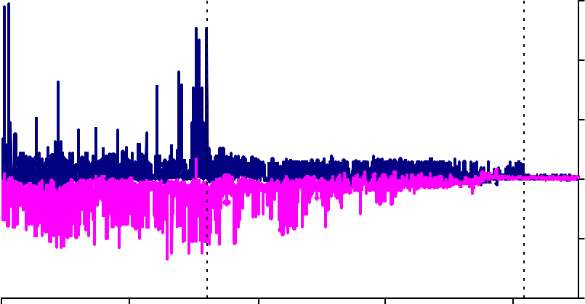

Extension of BoE lending facilities

MMR Interim Reforms

high

low

10

5

0

-5

-10

1994 1996 1999 2002 2004

Source: BoE calculations

Per cent

7

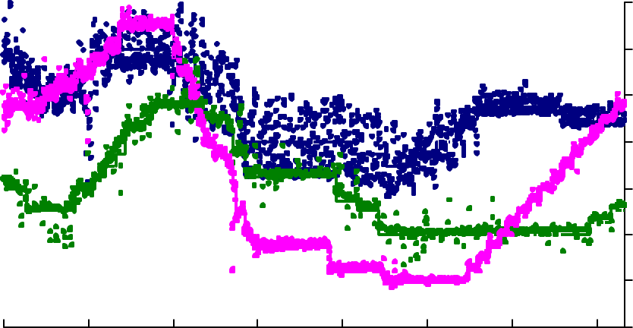

**£**

**€**

**US$**

6

5

4

3

2

1

0

1999 2000 2001 2002 2003 2004 2005 2006

Source: Bloomberg and BoE calculations

## Chart 3: Cumulative folded distributions of overnight/policy rate spreads

***Sample period: Jan 2002 - 11 Mar 2005***

50 50

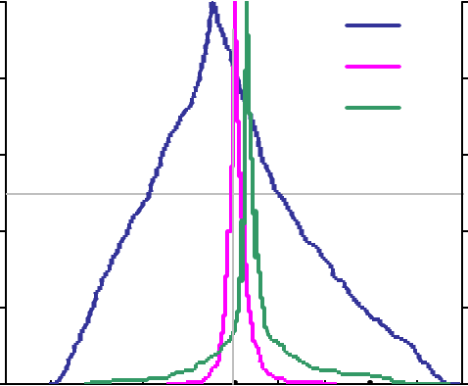

£

$

€

Interquartile Range

40 60

Cumulative frequency, per cent

Cumulative frequency, per cent

30 70

20 80

10 90

***Sample period: 14 Mar 2005 - May 2005***

50 50

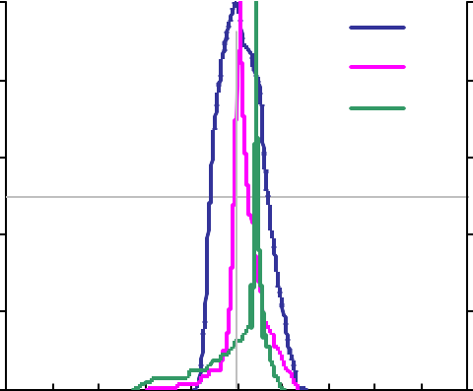

£

$

€

Interquartile Range

40 60

Cumulative frequency, per cent

Cumulative frequency, per cent

30 70

20 80

10 90

0

-1.0 -0.8 -0.6 -0.4 -0.2 0.0 0.2 0.4 0.6 0.8 1.0

100

0

-1.0 -0.8 -0.6 -0.4 -0.2

0.0

0.2 0.4 0.6 0.8 1.0

100

Percentage points Percentage points

£ billion

120

time deposits, repos and CDs

interest rate bearing sight deposits

100

80

60

40

20

0

1998 1999 2000 2001 2002 2003 2004 2005 2006

Source: BoE

## Chart 5: UK corporate sector retained earnings, investment and financial balance

% of gross operating surplus

80

Saving

(retained earnings)

Investment

Financial balance

60

40

20

0

-20

-40

1987 1989 1991 1993 1995 1997 1999 2001 2003 2005

Source: ONS

**(*average 2003-04*)**

Per cent of gross saving

60

50

40

30

20

10

0

UK US France Canada Italy Japan Germany G7 Note: Gross saving is defined as non-financial corporate profits after net interest and taxes, less dividends paid. Source: IMF

## Chart 7: Contributions to growth in UK non-financial company sterling deposits

Other

Legal, Accountancy & Other Business Activities Transport, Storage & Communication Wholesale & Retail Trade

Real Estate Construction Manufacturing

Utilities & Primary Industries Total

Percentage point contributions to

change on a year ago

12

10

8

6

4

2

1998 1999

Source: BoE

2000 2001 2002

2003

0

-2

-4

2004 2005

Per cent of gross corporate savings

50



40

30

20

10

0

1990 1992 1994 1996 1998 2000 2002 2004

Source: ONS

## Chart 9: Employer pensions contributions

£ billion, 2005 prices

60

50

40

30

20

10

0

1992 1994 1996 1998 2000 2002 2004

Source: ONS; data shown are expressed in 2005 prices using RPI inflation

1992 1994 1996 1998 2000 2002 2004

Note: Covers self-administered occupational schemes only

Source: ONS

## Chart 11: UK business investment

n

35

£ billio

Regular contributions

Special/one-off contributions Total employer contributions

30

25

20

15

10

5

0

2005

Per cent of GDP, constant prices

14

12

10

8

6

4

1990 1993 1996 1999 2002 2005

Source: ONS and BoE calculations

# percentage difference from trough in I/Y ratio

30

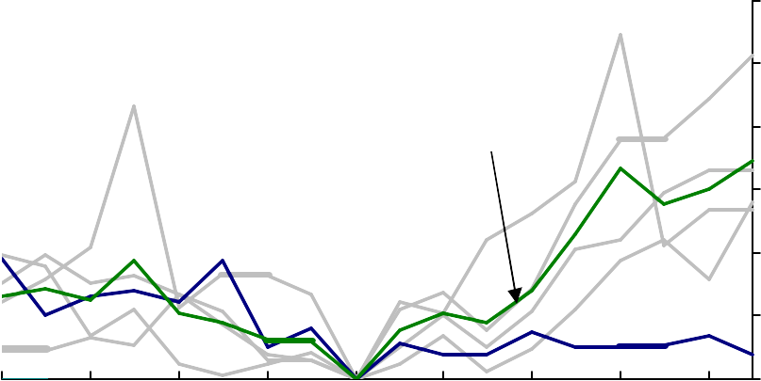

Average of past recoveries

Current

25

20

15

10

5

0

-8 -6 -4 -2 0 2 4 6 8

# quarters relative to trough

Source: ONS and BoE calculations

## Chart 13: Revisions to UK business investment

Percentage change on a quarter earlier

12

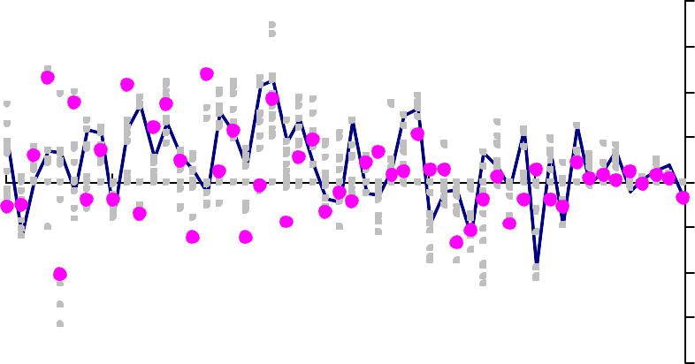

**Initial Estimates**

**Susequent**

**Estimates**

**Latest Data**

9

6

3

0

-3

-6

-9

-12

1993 1995 1997 1999 2001 2003 2005

Source: ONS

Per cent

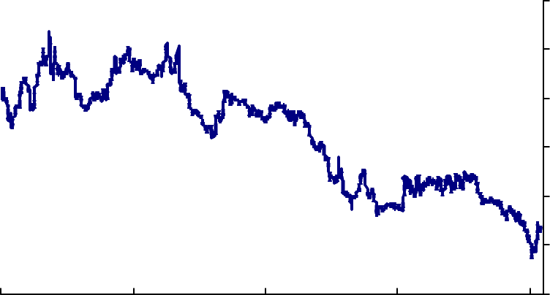6

5

4

3

2

1

0

1986 1991 1996 2001 2006

Source: Bloomberg and BoE calculations

## Diagram A: Stylised effect on equity returns of a fall in risk premia

One-period *ex-post* equity returns

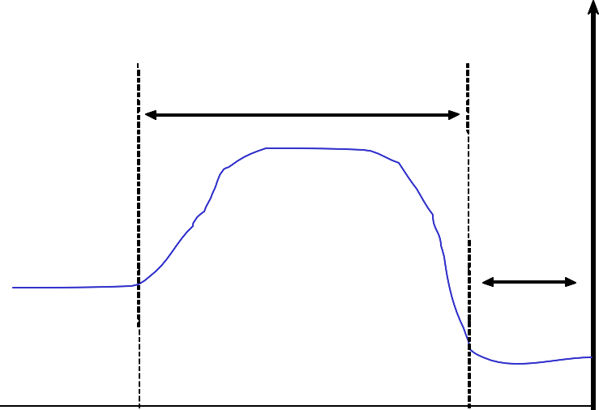

Time T

Time T+x

Premium falls by Y% each period

Pre- shock steady state returns

Post shock steady

state returns

time